Roaming Lizards and t-Tests

Background:
Habitat loss is a primary focus of conservation biologists concerned with endangered species resisting extinction. The effects of losing habitat depend on the home range size of a species but movement patterns are difficult to study in large animals with expansive home range sizes. Home range sizes are easier to study in smaller organisms. Biologists measured the home range sizes of Florida scrub lizards (Hokit and Branch 2003) by capturing and then recapturing individual lizards over a period of several months. Scrub lizards are a threatened species mostly because their habitat is rapidly disappearing and being replaced by houses, orange groves, shopping malls and golf courses. If activity areas (home ranges) differ between males and females, the effects of decreasing habitat patch size could affect males and females differently. The gender with the largest home range sizes will be impacted first by decreasing patch sizes.
A t-test is used whenever there are two data sets (groups/populations) representing two levels of an independent variable. You will use a simple t-test to test for differences between female and male home range sizes. Below are data for 37 females and for 46 males. The independent variable is sex and the dependent variable is home range size. The central question is whether sex has a significant effect on home range size. Be careful to include an assessment of normality. Home range sizes are notorious for being positively skewed. You may need to log-transform (base 10 or natural log) the data to meet the parametric assumption of normality. Use EXCEL to complete a t-test assuming equal variance. What is the p-value? Is there a significant difference between the sexes with respect to home range? If so, which sex has the larger/smaller home range?

Data:

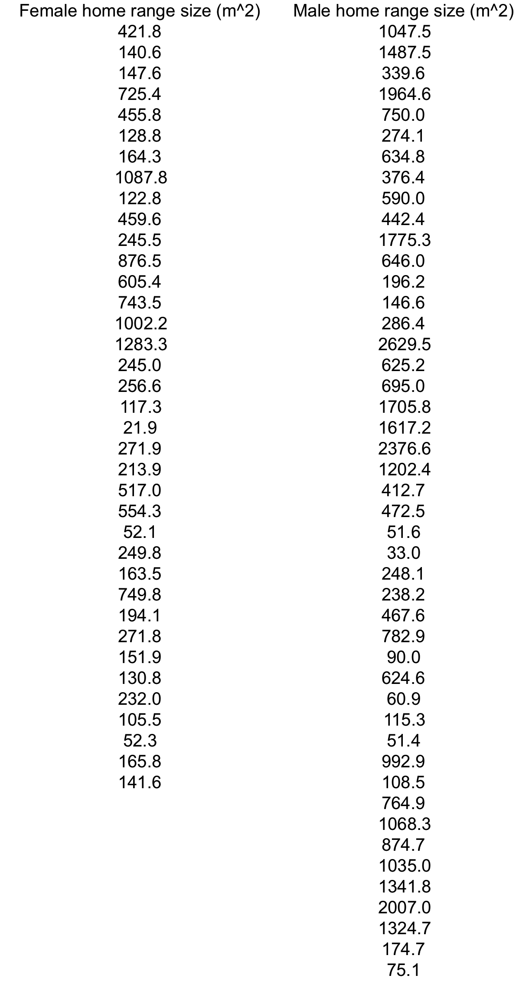
Hokit, D.G., and L.C. Branch. 2003. Habitat patch size affects demographics of the Florida scrub lizard (Sceloporus woodi). Journal of Herpetology 37:257-265

